Instruction:
Complete all questions in one hour.
- Which one is the characteristic of Harvard Architecture?
- Program and Data stored in Separate Memory
- Program and Data stored in same Memory
- Program and data stored in Cache Memory
- All of Above
- Which of the following is the working cycle of CPU?
- Decode, Execute, and Fetch
- Fetch, Decode, and execute
- Fetch, Execute, and Decode
- All of Above
- Any condition that causes a processor to stall is called as _________
- Hazard
- Page fault
- System error
- None of the mentioned
- What does the control unit generate to control other units?
  - Transfer signals
  - Command Signal
  - Control signals
  - Timing signals
- What must the processors of all computers have?
  - Control unit
  - ALU
  - Register
  - All of these
- Which is the fastest memory in the computer?
- Cache
- RAM
- Register
- Hard disk
- With the help of _______ we reduce the memory access time:
  - SDRAM
  - Cache
  - Heaps
  - Higher capacity RAMs

- For a given FINITE number of instructions to be executed, which architecture of the processor provides for faster execution?
  - ISA
  - ANSA
  - Super-scalar
  - All of the mentioned
- A processor performing fetch or decoding of different instruction during the execution of another instruction is called ______
  - Super-scaling
  - Pipe-lining
  - Parallel Computation
  - None of the mentioned
- A 24 bit address generates an address space of ______ locations.
  - 1024
  - 4096
  - 2⁴⁸
  - 16,777,216
- The USA contains about 3100 counties. Suppose you have a table that stores, for each county, its name (up to 40 characters in 8-bit ASCII), its state (a two-letter code), its population, and its median income (both as 32-bit numbers). How much space would the whole database take in memory?
- The computer has a maximum addressable memory of 16 Gigabytes. Its address bus width is 32.
- Calculate the width of the data bus.
- State the effect that adding one new line to the address bus would have on the maximum addressable memory.

- Explain the Instruction cycle of the processor by giving an example of the program
Load: [10]
Add : [11]
Store: [12]
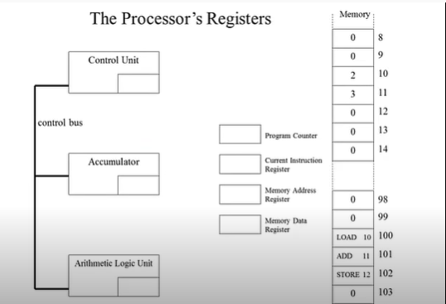

- Write short notes on the following topic:
- Von Neumann and Harvard Architecture
- RISC vs CISC architecture

